Let’s Vote System

Importing Candidates in CSV format:

For the Position:
[PositionDetail],<PositionCode>,<PositionName>,<AllowedVotes>
Where: PositionDetail - constant; to flag that the line is for position details
PositionCode - unique code for the position
PositionName - Position Description
AllowedVotes - Number of votes allowed for the position
For the Candidates:
<PositionCode>,<Name>,<Party>
Where: PositionCode - the position the candidate is running. Refer to PositionCode in Position detail
Name - Name of the Candidate
Party - Party of the Candidate

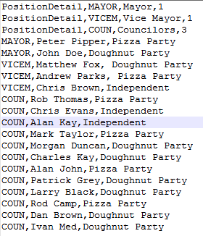

Database Dictionary:

Database Name: letsvotedb
SQL Script: CREATE DATABASE `letsvotedb`;

Tables:
Positions - Master table that holds all the positions imported from the CSV files
Field | Data Type | Remarks
Id | INT ; Identifier (Primary Key) | Position record identifier
positionCode | Varcher(15) | Position Code
positionName | Varchar(20) | Position Description
allowedVotes | INT | Number of votes allowed for the position

SQL Script: CREATE TABLE `letsvotedb`.`positions` ( `id` INT NOT NULL AUTO_INCREMENT , `positionCode` VARCHAR(15) NOT NULL , `positionName` VARCHAR(20) NOT NULL , `allowedVotes` INT NOOT NULL , PRIMARY KEY (`id`)) ENGINE = InnoDB;

Candidates - holds all the candidates imported from the CSV files
Field | Data Type | Remarks
Id | INT ; Identifier (Primary Key) | Candidate record identifier
position | Varcher(15) | Position Code the candidate is running.
name | Varchar(50) | Position Description
party | Varchar(50) | Number of votes allowed for the position

SQL Script: CREATE TABLE `letsvotedb`.`candidates` ( `id` INT NOT NULL AUTO_INCREMENT , `position` VARCHAR(15) NOT NULL , `name` VARCHAR(50) NOT NULL , `party` VARCHAR(25) NOT NULL , PRIMARY KEY (`id`), INDEX `candidatePosition` (`position`)) ENGINE = InnoDB;

Results - holds the voting results
Field | Data Type | Remarks
Id | INT ; Identifier (Primary Key) | Results record identifier
candidateid | Varchar(20) | Candidate ID
vote | INT | Vote Count

SQL Script: CREATE TABLE `letsvotedb`.`results` ( `id` INT NOT NULL AUTO_INCREMENT , `candidateid` VARCHAR(20) NOT NULL , `votes` INT NOT NULL , PRIMARY KEY (`id`)) ENGINE = InnoDB;

Design

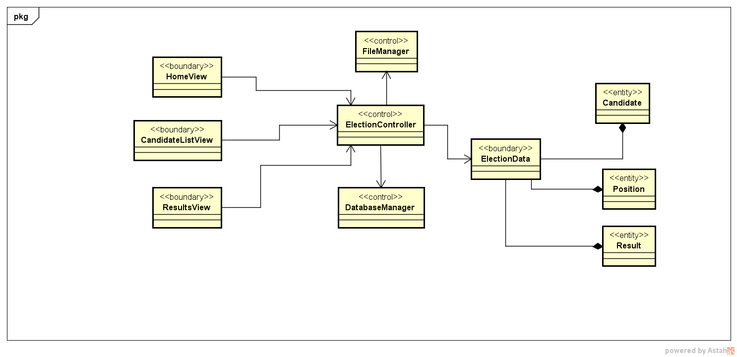

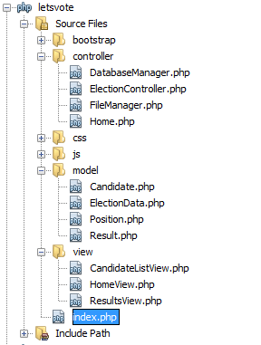

User Interface Design

URL: http://localhost/letsvote/

Allows the administrator to upload candidates from the CSV file. Once submitted, users can now cast their votes.



Page where the users can cast their votes or redirect to the page where the user can view the results of the votes.

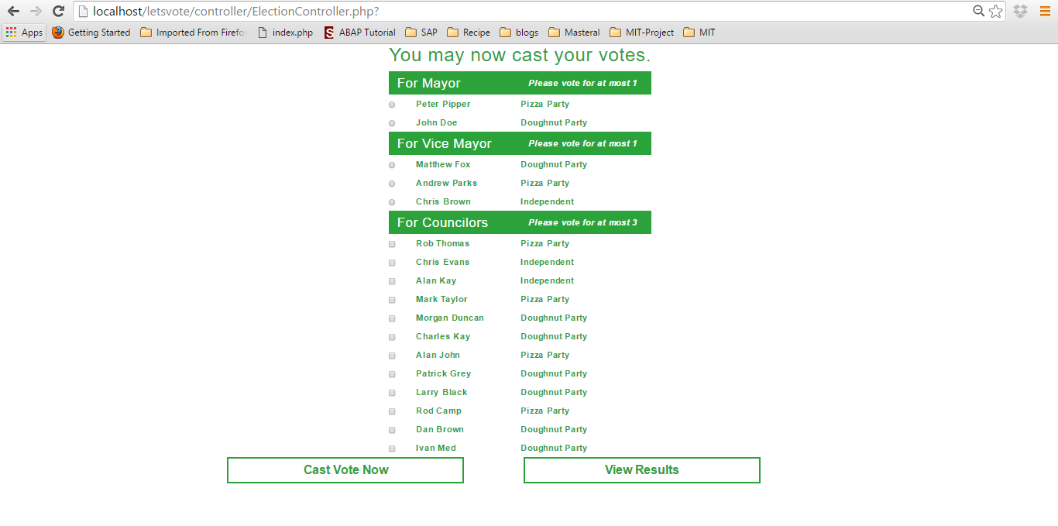

Page where the users can view the partial votes.

